PROCUREMENT DIRECTORATE CONVERGE TO TRAIN ITS STAFF

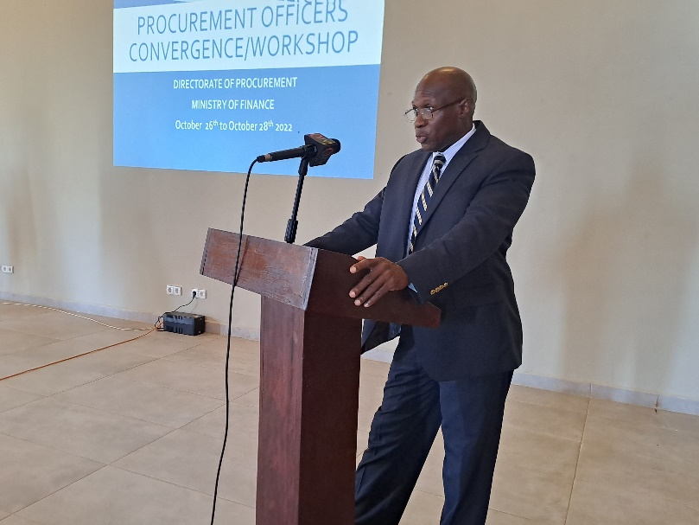
The Directorate of Procurement is on a 3-day convergence from the 26th to 28th of October 2022 at Sunset beach hotel to discuss the GPPA Act and other tools important to their work. Dr. John Solomon Jatta, the Procurement Director said that it's not business as usual in Procurement.
He urged officers to work hard to ensure that corruption is eradicated in the Procurement system. He added that procurement officers have the potential to sink or uplift this country with the work they do. Therefore, he encouraged them to adhere to the ethical principles surrounding their work. Finally, he thanked the Ministry for ensuring that the Cadre is backed by law.

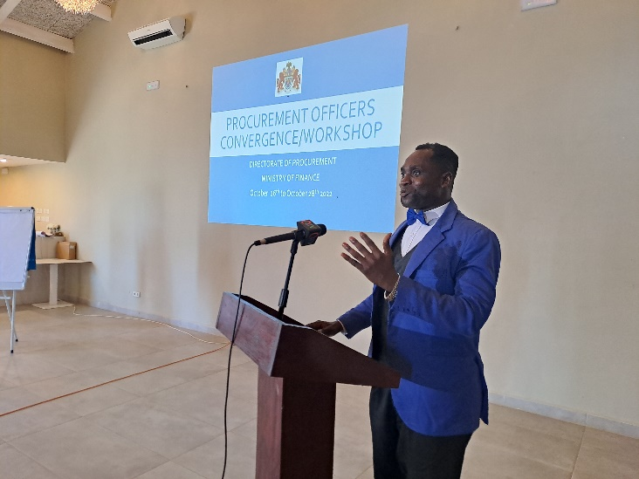
In his deliberation, Mr. Gomez, the head of the Gambia Public Procurement Institute told participants that the GPPA Act should be taken seriously by officers as they keep their holy books. In his words, “The Act is your Qur’an/Bible. Read it, understand it and execute it. You will save yourselves, your institutions, and the country”.
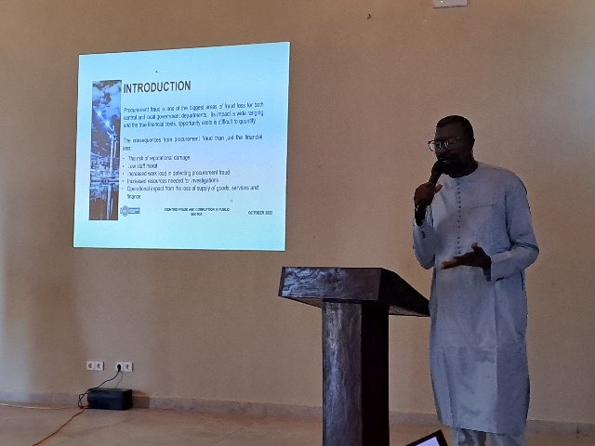
Mr. Modou Ceesay, the Director General of Internal Audit in his expression spoke at length about procurement fraud and red flags. He outlined that procurement fraud is one of the biggest areas of fraud loss for both central and local government departments. He added that its impact is wide-ranging and the true financial costs and opportunity costs are difficult to qualify. “The consequences from procurement fraud are more than just the financial loss. They include the risk of reputational damage, low staff morale, increased workload in detecting procurement fraud, increased resources needed for investigations, and operational impact from the loss of supply of goods, services, and finance”. He added.
On their part, participants took turns expressing their experiences: successes, and challenges in the execution of their work.
Ebrima S. Jallow

